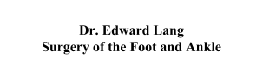
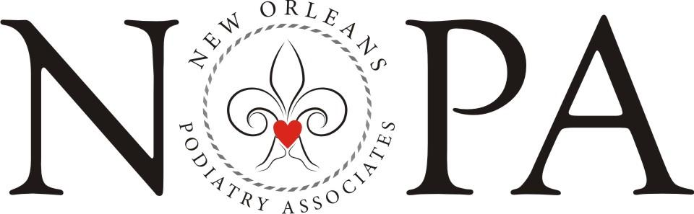
RECOMMENDED MEN'S SHOE LIST

- Birkenstock (Dress Shoes and Sandals)
- Borne
- Brooks Tennis Shoes
- Cole Haan with Nike technology (Wingtips style may be available)
- Crocs Rx
- Dankso Shoes and Clogs
- Ecco (Dress or Jogging)
- Florsheim (Wingtips style may be available)
- Jogging shoes (Nike, New Balance, Asics, Saucony)
- KURU—Staff Favorite! (Available Only at kurufootwear.com)
- Merrell
- Naot
- Rockport (Wingtips style may be available)
- SAS
- Vionic with Orthaheel Technology and 30-day money-back guarantee—Staff Favorite!
(Available at Zappo’s, Amazon, or vionicshoes.com)

Most brands can be found at stores such as Dillards, Perfect Fit Shoes, Amazon, & Southern Runner
New Orleans Podiatry Associates
2626 Jena Street, New Orleans, LA 70115 t. 504.897.3627 f. 504.897.3339
3939 Houma Blvd, Bldg. 5, Ste. 217, Metairie, LA 70006 t. 504.457.2300 f. 504.897.3339
nolapodiatry.com nolapodiatry@gmail.com

